Microsoft

First Response Demo

Last updated: 3/23/2017

|  |  |
| --- | --- |
| **Microsoft Contact**  Tara Shankar Jana  Sr Product Marketing Manager  Data Platform & IoT Mktg  [tarasha@microsoft.com](mailto:tarasha@microsoft.com) |  |

# Introduction

First Response Online is a communication and collaboration platform built to support first responders. It lets police officers, fire fighters, and paramedics share critical data with each other in near real-time. It supports iPhone, iPad, and PC and integrates with computer aided dispatch and GPS tracking. Units in the field can update their status, complete traffic stops, and even query state & federal databases all without using the radio.

First Response Online is powered by Azure. In order to build a business that handles major life-threating incidents, they not only rely on Azure’s proven scalability and availability but also its breadth of features to get to market quickly. By using services like App Service, Azure SQL, DocumentDB & Azure Search, First Response Online can instead focus on empowering first responders instead of maintaining infrastructure.

# Hockeyapp

You will find all the instructions to get up and running locally in this repository <https://github.com/Microsoft/demo-first-response-online>.

If you need a quick start you can follow this process to get you access to a pre-deployed version through HockeyApp.

1. Create an account in <http://hockeyapp.net> if you don’t have already one.
2. Ask the Microsoft Contact at the beginning of this doc to grant you access.
3. He will send you an invite.
4. Once you have been invited you can login and you will see three **First Reponse** apps (one for each supported platform).
5. You can go to the First Reponse app for Windows and click Download.
6. Extract the zip file and right click on **Add-AppDevPackage.ps1** file > Run with PowerShell

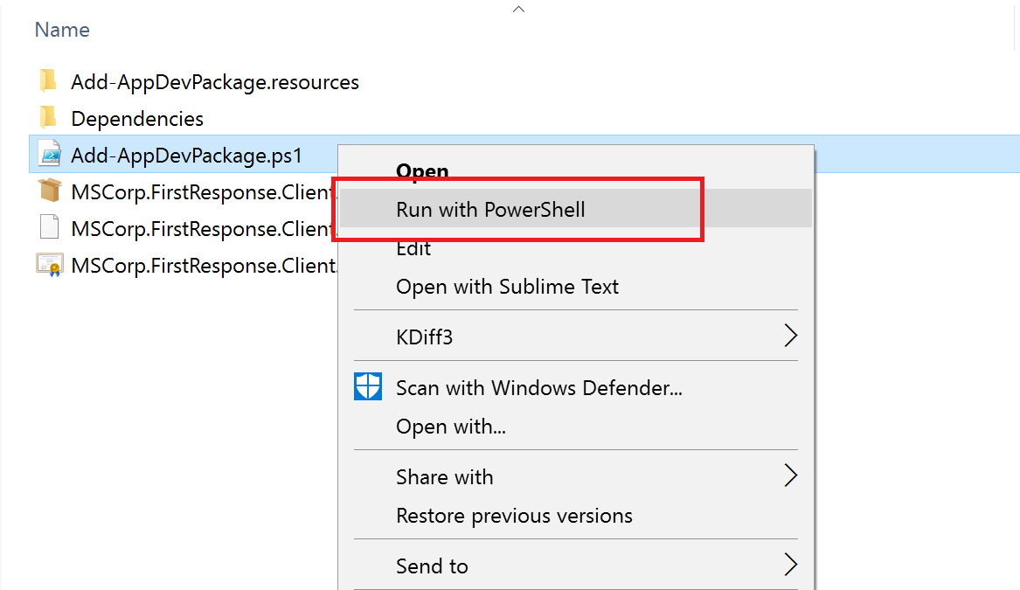

1. Trust and Install certificate in order to get this development package running locally. Once this script is done you should see something like

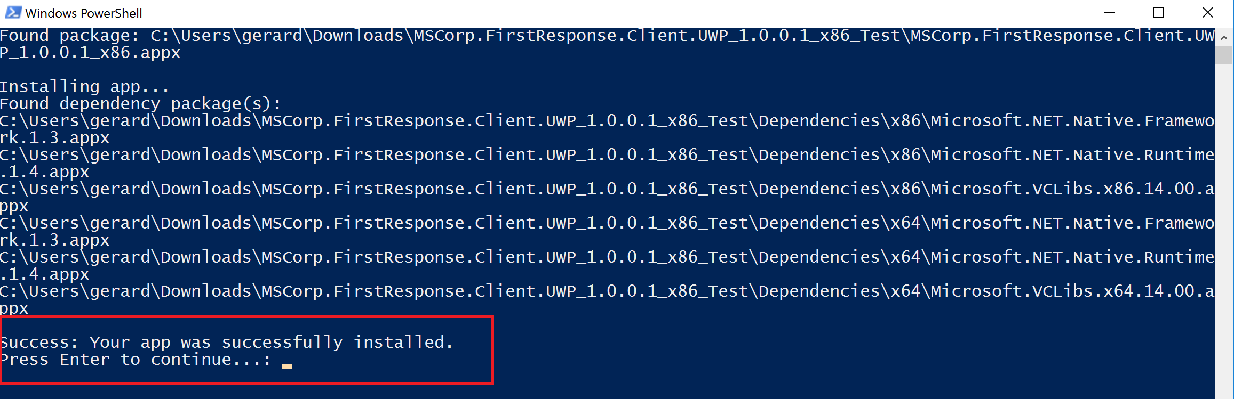

And finally it will show up in your Windows searches

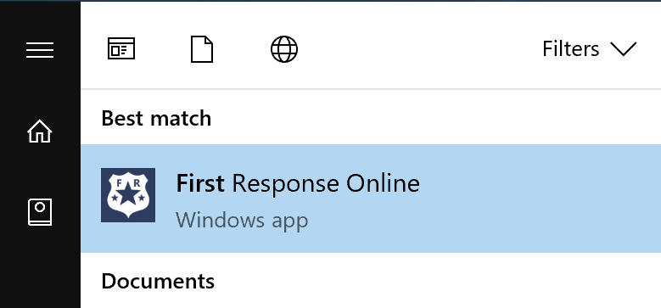

1. For Android and iOS you will only need to login in a supported device and download/install the app.
2. For iOS devices after installing the app you will need to go Settings > Device Management > Trust Microsoft Corporation